Vision and Scope Document

for

myKSU Student Mobile Application

Prepared by:

|  |
| --- |
|  |
| Brandon Merck: *Coach, Developer*  bmerck@students.kennesaw.edu  Alix Teschner: *Developer, Tester*  ateschne@students.kennesaw.edu  Ethan Dillon: *Developer, Tester*  edillon7@ students.kennesaw.edu  Joshua Gregory: *Developer, Tester*  jgrego42@students.kennesaw.edu  *Delivered 04 Feb. 2025*  Table of Contents | |

|  |  |
| --- | --- |
| Table of Contents.................................................................................................... | ii |
|  |  |
| 1. Business Requirements.................................................................................. | 1 |
| 1.1. Background............................................................................................ | 1 |
| 1.2. Business Opportunity............................................................................. | 1 |
| 1.3. Business Objectives............................................................................... | 2 |
| 1.4. Vision Statement.................................................................................... | 3 |
| 1.5. Business Rules....................................................................................... | 4 |
| 1.6. Business Assumptions and Dependencies............................................. | 5 |
|  |  |
| 2. Scope............................................................................................................... | 7 |
| 2.1. Major Features....................................................................................... | 7 |
| 2.2. Feature Tree Diagram............................................................................ | 9 |
|  |  |
| 3. Business Context............................................................................................ | 10 |
| 3.1. User Profiles .......................................................................................... | 10 |
|  |  |
| 4. Diagram and Sketches.................................................................................... | 11 |
| 4.1. Context Diagram.................................................................................... | 11 |
| 4.2. Prototype UI Sketches ........................................................................... | 12 |
| 4.2.1. Digital Simulation of Prototype UI............................................. | 12 |
| 4.2.2. Images of Major Screens.............................................................. | 12 |
|  |  |
| 5. Credits............................................................................................................ | 15 |

# Business Requirements

## Background

Kennesaw State University has been using the Owl Express website for years to allow students to register for classes, view their schedules, and pay their tuition all in one place. But despite more and more colleges creating mobile apps to allow students to view and interact with this information on the go, KSU does not have a mobile app equivalent to Owl Express. And as the next generation continues to be more dependent on their mobile devices, it is becoming more necessary to have an app equivalent for every internet service. And while Owl Express is a functional and helpful tool, its design is not well suited for mobile viewing, which is especially important for things as important as registering for classes or making tuition payments.

But not only does the lack of an Owl Express app make KSU fall behind technologically, but it makes it harder for students in an increasingly mobile world. College students lead very busy lives, and because of this it is easier to miss important deadlines like registration times and tuition due dates, especially with young people who do not use or check their email as much as previous generations.

[Ethan Dillon]

## Business Opportunity

Our product, myKSU, will bridge KSU’s digital gaps with four key improvements:

1. Student Connectivity

According to Pew Research, 98 percent of Americans between the ages of 18 to 29 own a smartphone, but 21 percent of Americans in that same age range say they do not have internet access at their home, meaning that they are “smartphone dependent” ([Pew Research Center, 2024](https://www.pewresearch.org/internet/fact-sheet/mobile/)). This means that many college students can only connect to the web via their phones at home, making it very difficult to access key services such as registering for classes or viewing your schedule when away from campus. myKSU would fix that by giving students an intuitive mobile app that they can access on the go from their phone.

1. Competitive Market

Universities across the country, including many in Georgia, have already implemented similar apps for their institutions. For example, the University of Georgia has an app called UGAMobile which allows users to view their schedule and add and drop classes. By implementing myKSU, Kennesaw State University would be on par with the biggest and best colleges in the country, and in a world where students are increasingly focusing on technology it is important to stay on the cutting edge.

1. Improve User Experience

While the current Owl Express website is very functional on the desktop, the mobile website can be difficult to navigate and find the information that you need. But with the myKSU app, navigating and accessing information will be simpler and more intuitive. When using a desktop web application on mobile, the worst part is the way that the buttons scale because of the change in modality; using touch controls means that it is harder to have precise control on your input, which is usually not accounted for in web development. However, with the myKSU app, the product will be designed from the ground up for mobile users, making the experience intuitive and seamless.

1. Drive Timely Payments and Enrollment with push notifications

The current Owl Express system uses emails to communicate important dates and deadlines to students. But with the prevalence of social media, a conventional push notification system will be more helpful to students. But not only that, this notification system will decrease the amount of late tuition fees, decrease the net number of classes dropped, and increase the number of classes signed up for because students will be notified when tuition is due, when registration begins and ends, and if a class they have waitlisted gets an opening. It will also make all of these systems much simpler to navigate, especially tuition payment because we can use proprietary technology like Apple Pay.

[Ethan Dillon]

## Business Objectives

1. Launch product in Spring 2026 to coincide with Fall 2027 registration.
2. Increase classes enrolled by 6% within the first 12 months.
3. 80% of students download and use the product within the first 8 months.
4. Decrease IT support calls by 20% within the first 12 months.
5. Decrease net classes dropped by first-year students by 20% within the first 18 months.
6. Decrease net classes dropped by all students by 10% within the first 18 months.
7. Decrease late tuition payment by 7% within the first 8 months.

[Ethan Dillon]

## Vision Statement

**For** students **who** need a solution for convenient and responsive access to viewing and editing Kennesaw State University data and completing processes, including viewing currently enrolled courses; unenrolling courses; searching courses per semester and filtering by area of study, course name, and course number; viewing course information and enrolling a new course; viewing enrolled courses of previous semesters; viewing and paying outstanding fees; viewing payments history by semester; viewing system-generated course recommendations based on major and standing; building, editing, and exporting a digital schedule; receiving FAQ answers, prestored responses, basic KSU information, and general assistance from a digital advisor; and viewing and editing their user profile, **the** myKSU student companion app **is** a modern mobile application system for iOS and Android platforms that provides this solution. The myKSU architecture will interface with existing KSU systems to provide student users with secure, on-demand access to the above features through an intuitive UI. **Unlike** KSU’s current paper-based operations and unresponsive web application, **our product** will improve student experience and success by allowing student users to perform important education tasks and access their data anywhere and anytime. myKSU will place the ability to track and edit their education experience in the student’s hands, to a safe and secure degree. This will remove the need for student’s to wait until they can use a desktop and also decrease the elevated number of inconvenient office visits. Our product will also rebrand the university as a modern, higher-education destination for 21st century students, increasing revenue through increased enrollment, decreased unenrollment, and easier fee payment. myKSU will decrease administrative workloads and costs by decreasing paper-based and office workstation operations. Additionally, modern data management will decrease IT workload and resource cost by automating tasks that are currently manually performed by IT personnel. myKSU will also distribute the workload being placed on university servers and networks, further reducing resource cost. Furthermore, by analyzing exponentially increasing user data generated from the expanding user base, myKSU will provide the university business managers with increasingly better-informed trend analyses.

[Joshua Gregory, Brandon Merck, Alix Teschner, Ethan Dillon]

## Business Rules

1. **We need to ensure we have frequent checkups.** This should come in the form of virtual meetings, text messages, email and/or face to face meetings.
2. **We need to document all events and tasks.** In other words, every notable task or meeting or page of notes should be documented in a consolidated area all members have access to.
3. **Google Drive will be the main source for documentation housing.** All of our documents and notes should be stored there as a central hub for the group.
4. **Our team meeting notes should be updated every two weeks**. This is not an arbitrary number, rather the number given directly by our elicitation questions.
5. **Our project needs to fall within the guides of federal law, university law and with the course guidelines**. Nothing we do or create should violate any of these rules.
6. **If the client makes a request for change, we need to address that change as soon as possible.**  Feedback suggests that our entire project could be redirected based on client request. We should be prepared as a group to put our heads together and make that change happen as fast as possible.
7. **Owl Express is generally the system we will be modeling our system on, but plagiarism will not be tolerated.**  We will use Owl Express as a guideline to see what a successful system looks like, but no copying of systems exactly.
8. **Everyone is expected to give 100%, else be replaced.**  We are a team, and are expected to act as much. A vote can be cast to remove a group member if they prove to not be contributing, which will be formally submitted to the professor for review.
9. **If you cannot fulfill your role for a given deadline, you will tell the group as soon as possible.** We should hold ourselves to higher standards, and if you need help with a portion that has been assigned to you, you will NOT wait until the last minute to tell the group.
10. **Student users must be logged in to view their information.** To prevent unauthenticated sign-in attempts, an identifier (e.g. IEM number) from each device on which a student installs and logs-in to myKSU will be stored as a user data record. Once a device is registered to a account, no other account can log-in to myKSU using the device until it has been removed from the student’s user data by IT personnel.
11. **Students must not be able to access or edit official Kennesaw State University records in any way.** Official university records cannot be accessed or edited in any way. The myKSU system will not integrate with secure, official university records.
12. **Administrative personnel must be able to create, read, update, and delete** myKSU **student accounts.** On-premises, lower-end workstations used by administrators must be integrated with myKSU data.
13. **Student users with class standing of freshman cannot register upper-level courses when using** myKSU**.** Courses with course numbers of 2000 or above must be made unavailable to freshman students. The myKSU system must be able to identify freshman users, via class standing, and course level, via course number.
14. **Payment authentication is not required.** With security measures already in place, payments will not require students to enter credentials or identifying data to process payments as the student is already logged-in to their account from their registered device.

[Brandon Merck]

## Business Assumptions and Dependencies

What we are creating is an app, and as listed above it will be for IOS and Android devices, to allow students to manage their school schedule. Owl Express should be used as a general guideline but we need our product to be unique in its appearance.

Students should have access to their accounts, be able to register and unregister from classes, view previous activity on their account, manage tuition fees and registration fees, have access to a digital advisor and a digital schedule builder, and get recommended classes based on the student’s major.

The project is broken down into 5 parts, that being the scope document, system models, requirements list, inspection report and then the prototype with a peer review. There is also a video presentation required. Right now, the assumption is that there will be an equal amount of time for each section of the project to get finished.

Group 8 is supposed to simulate being a cooperate entity, being located in Atlanta and having more staff members than there are group members. The professor is our client and will be simulating proper interaction with a customer. This means we need to be professional and find ways to express that professionalism in everything we do, whether that be through emails to our client, the prototypes we deliver, or even just in the notes we make.

There is an assumption that this course will not heavily focus on coding, rather have our focus on what the requirements for such a product would be.

As the producer of this student registration app, we assume that the client will give us all of the details on what they’d like included in their product. However, we need to be open to change, and coordinate with each other in order to manage both our time and our client’s time as effectively as possible.

[Brandon Merck]

# Scope

## Major Features

* User Profile CRUD
  + Create user profile
    1. Check DB for existing record
       1. Finish profile or prompt login
  + Read user profile
    1. View profile details & picture
  + Update user profile
    1. Edit profile details & picture
  + Delete user profile
    1. Delete user profile
* Pay Registration and Tuition Fees
  + View balances & past payments
  + Enter payment amount & method
    1. Credit / debit card
    2. Bank transfer
    3. Other (Apple Pay, Google Pay, PayPal, etc.)
  + Generate payment ID & confirmation email
* Enroll in Courses, Unenroll from Courses, View Past Activity
  + Enroll courses
    1. View catalog for selected semester
    2. Search & filter catalog
    3. View description for a selected course
    4. Select a course to add and confirm enrollment
  + Unenroll from a class
    1. View currently enrolled courses
    2. Select a course to unenroll and confirm
  + View past activity
    1. Select semester
    2. View courses enrolled & unenrolled
    3. View final grades for courses
* View Recommended Courses (based on major and class standing)
  + Personalized course suggestions
    1. Filter catalog based on major & class standing
  + View course descriptions
* Digital Schedule Builder
  + View weekly timetable
  + Drag-and-drop automatically added courses
  + Add custom entries
  + Edit time intervals for courses & custom entries
  + Remove courses & custom entries
  + Export schedule
* Digital Advisor
  + Provide key student info (GPA, class standing, academic status, etc.)
  + Provide key university info (semester start dates, add/drop windows, etc.)
  + Respond to student questions.
  + Student services & student support links & contact info
  + Navigation to other app features

[Joshua Gregory]

## A diagram of a company Description automatically generated with medium confidenceFeature Tree Diagram

[Joshua Gregory]

# Business Context

## User Profiles

|  |  |  |  |  |
| --- | --- | --- | --- | --- |
| **Stakeholder** | **Major Value** | **Attitudes** | **Major Interests** | **Constraints** |
| Business Management & Investors | Increased revenue | Concerned about budget & schedule.  Excited for reducing admin & IT costs, increasing productivity, and giving the university a modern rebrand. | Increase market position & enrollments.  Increase data analyses.  Streamline operations.  Increase users & enrollment. | Must pass tests for compliance.  Must stay in-budget & on-time. |
| Administration Faculty | Reduced workload | Receptive but concerned that reduced workload may lead to staff reductions.  Concerned about being able to help students with app related questions. | Increase productivity.  Improve student experience & success.  Decrease workload and paper forms. | Must be trained on app use to help students.  Must have low-end workstation access to key student data & CRUD operations for student account and profile data. |
| IT Faculty | Easier data management for expanding user base | Focused on integration & quality attributes like scalability & security.  Concerned with poor UI/UX increasing technical support load. | Maintainability and scalability with growing number of users  More dynamic and modern environment.  Automation of backend processing & data management tasks. | Must be able to integrate with existing systems while official records remain secure.  Must be trained on system to maintain & provide support.  Should be scalable & maintainable. |
| Students | Convenient, quick access to features | Excited to have mobile option for registration & fees.  Concerned about security & ease of use. | Convenient access to key info & student data.    Improve UX over outdated system. | Must be intuitive & secure.  Must only have access to their own data & only when logged in.  Must not be able to access official KSU records. |

[Joshua Gregory]

# Diagrams and Sketches

## Context Diagram

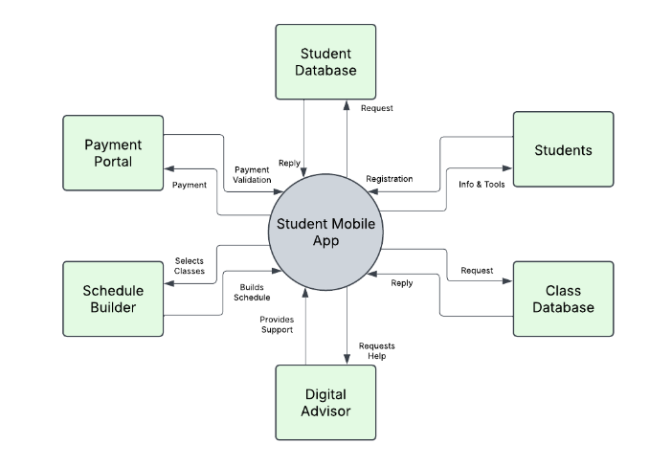

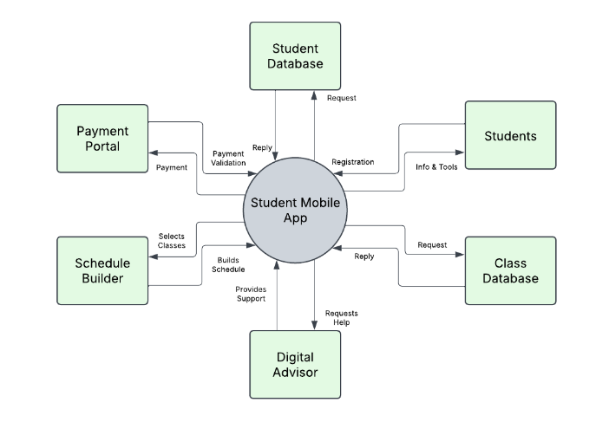

[Alix Teschner]

## Prototype UI Sketches

### **Digital Simulation of Prototype UI:**

Use this link to view and interact with an HTML simulation of the myKSU prototype UI. No log-in or install is required.

* + [View simulated myKSU UI prototype](https://cloud.justinmind.com/usernote/prototype/3586a4bb75fa2659fc1ac76f1084f368a24fc31a929d1f9eece5bd5266daf047)

Please note:

* + The simulation is currently configured for vertical (portrait) view.
  + User Profile is accessible from the person icon at the top-right of Main Menu.
  + The links at the bottom of screens open KSU homepage and UITS in new tabs.
  + All navigation is interactive. Buttons or links tied to stored processes or data are not as no database exists. E.g., processing payments, exporting schedules, Digital Advisor responses, uploading files.
  + The file select widget in Edit Profile will allow viewers to select a file. The upload icon will not actually upload but is tied to an event to simulate picture editing.

[Joshua Gregory]

### **Digital Simulation of Prototype UI:**

[Joshua Gregory]

# Credits

Alix Teschner – Developer & Tester

* 1.4. Vision Statement
* 4.1. Context Diagram

Brandon Merck – Coach & Developer

* 1.4. Vision Statement
* 1.5. Business Rules
* 1.6. Assumptions & Dependencies

Ethan Dillon – Developer & Tester

* 1.1. Background
* 1.2. Business Objectives
* 1.3. Business Justification
* 1.4. Vision Statement

Joshua Gregory – Developer & Tester

* 1.4. Vision Statement
* 2.1. Major Features & Tree Diagram
* 3.1. User Profiles
* 4.2.1. Digital Prototype
* 4.2.2. Major Screens